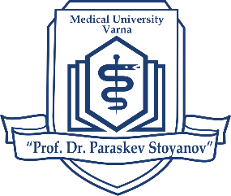

EIGHTH INTERNATIONAL PARTNERSHIPS FORUM
DEVELOPING COMPETENCES AND SKILLS THROUGH INTERNATIONALIZATION
19 October 2023
Programme
10:00 – 10:30 | Opening and greeting addresses. Scope and purpose of Forum 2023
Anniversaries and Internationalization

10:30 – 11:15 | Strategic partnerships and projects in the field of public health  dedicated to the 60th Anniversary of the Department of Social Medicine and Health Care Organization​
11:15 – 11:45 | Caring for our children in cooperation with our international partners  dedicated to the 60th Anniversary of the Department of Pediatrics
11:45 – 12:30 | Preparing the future leaders in health care together with international partners. 30 years of successful development and partnerships in the field of health management  dedicated to the 30th Anniversary of the Healthcare Management Specialty
12:30 – 13:15 | Partnerships between academia and business in the field of pharmacy  dedicated to the 15th Anniversary of the Faculty of Pharmacy
13:15 – 13:30 | Closing remarks

